Personnel responsible:
All

Safety:
Safety shoes and safety glasses are required when working in the plant.
Safety Belt is required when operating a Fork Lift

Summary:
All finished crystal product is staged in Upper or Lower warehouses located adjacent to the packaging and press area. Finished crystal product is staged in the warehouses as full loads for ease of tracking and loading. The loading dock is located adjacent to the Lower Warehouse. Giles can only load one truck at a time. Numerous Drivers can be staged in the parking area on Miller Street to simplify loading and street congestion. All arrangements, including paper work, for shipping and transfers are handled by the Lead Customer Service Representative or Accounting Associate.

Procedure;
- When a driver shows up for a load he is to ring the buzzer out side of the warehouse door. First available employee should answer the door, and ask the driver for his pick up number. The driver is allowed to come in the building but they are to remain in the designated areas. Operator should reference the pick up number to the loading board. If a matching number is found proceed to item number 2 of this procedure. If there is no matching number, first ask the driver which street address he is picking up at. He could be at the wrong address. If he is at the correct address, the driver must call his dispatcher for and get a correct number.
- Find the corresponding Bill Of Lading (BOL ) that matches the pick up number out of the BOL box. Take the BOL to the driver, show the driver the amount and weight of the order. Have the driver initial beside pick up number stating it is the correct number. Using the "Truck Loading Time" stamp, stamp the top sheet ( pick slip ) of the BOL and then use the time clock to clock the driver in beside "Truck Arrived"
- If there is no truck in the dock, show the driver where to back in. If there is a truck already in the loading dock being loaded, give the driver a pager with directions to the Miller Street staging area. Loading is first come first served so we Load drivers in the order in which they are clocked in.
- Locate the bin number beside the order on the shipping board, if no bin number is indicated, find a load completely matching order description in the warehouse. The loader should carefully read the order information both on the Pick Slip and the BOL in order to insure the correct amount and product is loaded. It is the loader's responsibility to make sure the Special Customer Requirement ( SCR ) code is followed. The SCR number is located on the Pick slip and the BOL. The SCR information is on the Documentation system.
- As the driver is backing into the dock, it is good practice to stage the load. Begin taking the pallets from their bin and place them in an orderly manner near the loading dock for easy and quick loading.
- Trucks are to be loaded according to the loading chart on page 7 of this procedure. If a driver would like to be loaded a different way it can be done but it is the driver's responsibility from that point forward. The driver is to be informed if it is off weight on the axes we do not take responsibility and will not unload once it has left Giles premises.
- If the truck is not present during loading, jack stands much be placed under the trailer while loading.
- While loading the truck, fill out the second page of the pick slip with checking each pallet for SCR Code compliance, hardness, print quality and leaking or torn bags. DO NOT LOAD if items are unacceptable.
- Fill out a corresponding Certificate of Analyses ( C of A ) to be sent with the load.
- After the truck is loaded, on the Pick Slip the loader signs and dates pallet check and clocks the driver out using the time clock beside the "Loading Completed" section of the "Truck Loading Time" stamp. Both the Loader and the Driver must initial loading times stating when the truck arrived and when it was finished loading.
- On the BOL the loader writes down Trailer number in vehicle number slot. The Lot number and the Seal number is to be written in the center section. The loader should then sign, date and put the time loading and paper work was completed in the designated area at the bottom. Have the driver sign and date in designated area. Keep the top copy for the office. Give the driver the second copy. Fold the third copy of the BOL with a Certificate of Analysis and any other customer required paper work. Put third copy and all other paper work in a shipping pouch, peal off the paper revealing the self adhesive back and attach to the last pallet on the load.
- Physically put the seal on the truck after it pulls away from the dock and driver closes the trailer doors.
- Sign off the load on loading board and place finished paper work in the BOL box ready for office pick up.

CRYSTAL LOADING CHECK LIST

- Get pick up number from the driver
  - If no matching number, driver must call their dispatcher
  - GILES DOES NOT LOAD WITHOUT A PICK UP NUMBER
- Match number from the Driver with the load on the Load Board and then get the correct Bill of Lading from BOL box.
  - Driver must initial Pick up number before being clocked in.
- Clock Driver in immediately using supplied stamp and digital time clock.
  - If more than 1 truck is waiting, assign pager and send driver to Miller Street.
    - Write pager number on the pick sheet of BOL
- Check BOL and or pick slip for Special Customer Requirements ( SCR Code )
  - Find correlating SCR code on the Documentation System.
- Check BOL for product ID and product amount needed for the load
- Check EACH AND EVERY pallet for;
  - SCR compliance
  - Wrap not torn
  - Pallet in good condition. No torn or leaking bags

Print on pallet clear ( both from printer and operator )

Bags feel soft ( not crunchy or hard )
- Check Length of Trailer before loading
- Use Trailer Stands if Tractor is will not be under the Trailer during loading
- Load Truck according to Giles policy - loading chart
  - Contact Plant Manager, Production Manager or Customer Service Representative before adjusting any load amount.
  - With a single line mark though any corrections on all paper work
  - Legible write in the new amount and weight to be loaded, and initial beside each.
  - On the top sheet of pick slip write down the reason for shorting the load.
- Fill out the second page of the Pick Slip with proper information ( while loading )
- Loader must sign off on “checking load conditions box” on the Pick Slip
- Get a matching Certificate of Analysis for each lot number in the load.
- Put Trailer number, Seal number and Lot Number on BOL
- Clock driver out on the Pick Slip - Have driver initial times.
- Loader and Truck Driver Signs BOL with Date and 24 hour time.
- Copies of the Completed Bill of Lading
  - Giles gets top copy.
  - Driver gets second copy.
  - Fold third copy and place in a shipping pouch with all other customer related papers and stick to shrink wrap on the last pallet of the load in the truck.
- Put seal on Truck
- Sign load off on shipping board and place paper work in "shipped box"

PICK SLIP

The Pick slip is the top sheet of a Bill of Lading or BOL. The Pick Slip is generated by the Customer Service Department when a Customer places and order. This is a quick reference of the BOL and customer order, this is information telling the loader what material and what amount the customer has ordered.
Get Pick up number from driver, compare number to Loading Board. Then find the corresponding BOL and Pick sheet.
Have Driver initial beside the Pick Up number on the pick slip.
Clock Driver in using Time Clock
Check Product code and Amount needed.

Check off what location you are shipping the product from.
Check the condition of pallets, bags, print, hardness and SCR number before loading product. Sign off stating you have checked everything and it is acceptable.
SCR code is the Special Customer Requirements for the customer.

Pick Up Number (Driver Initials here)
Shipping Location
Pick Slip

Customer - Customer name BOL NUMBER : ~~~~~~~~~~~~~~~
CUSTOMER PO NUMBER ~~~~~~~
3RD PARTY PO NUMBER ~~~~~~~

Ship To: Ship From
Customer Name and  102 Commerce Street
Ship to address  396 Smathers Street
 202 Lea Plant Road
State  _________________

Condition of pallets, bags/boxes, print hardness or salt and the SCR has been checked on this load
NAME ____________________________ DATE ____________ TIME ____________

T-50 882
Tech Grade Epsom Salt in 50lb bags
SCR # 23

Pick Slip

Customer - Customer name BOL NUMBER : ~~~~~~~~~~~~~~~
CUSTOMER PO NUMBER ~~~~~~~
3RD PARTY PO NUMBER ~~~~~~~

Ship To: Ship From
Customer Name and  102 Commerce Street
Ship to address  396 Smathers Street
 202 Lea Plant Road
State  _________________

Condition of pallets, bags/boxes, print hardness or salt and the SCR has been checked on this load
NAME ____________________________ DATE ____________ TIME ____________

T-50 882
Tech Grade Epsom Salt in 50lb bags
SCR # 23

Number of bags
needed
Product Code and Description
Sign off stating you have checked material and it is acceptable

SCR Code - Check
Documentation System for instructions

Truck Loading Time
Truck Arrived __________________
Loading Completed _____________
Driver ________ Loader ________

Clock driver in after matching up pick up number

PICK SLIP PAGE 2

The Second page of the Pick slip is for documenting the pallet information as it is being loaded on a truck. This is also key information for the Customer Service Department as well as the Quality Control Department and Inventory control.

If two or more different lot number, operator, or production dates are loaded, each lot number, operator number or date must be entered.
When drawing lines to indicate all the same, write in the first and last of numbers and dates and draw line connecting them.

As you load the product on a truck, check each pallet for SCR requirements, Print clarity and Salt condition. Check each box for each pallet
A line may be drawn to indicate that all are the same. Line may be drawn for Item, Lot Number, OPR and Production date only.



PICK SLIP - PAGE 2
 |   SCR |   PRINT |   SALT | ITEM | LOT  NUMBER | OPR | PRODUCTION DATE
1
2
3
4
5
6
7
8
9
10
11
12
13
14
15
16
17
18
19
20
21
22
23
24

OPR Initials ___________ Date : ____ / ____ / _____

PICK SLIP - PAGE 2
 |   SCR |   PRINT |   SALT | ITEM | LOT  NUMBER | OPR | PRODUCTION DATE
1 |  |  |  | T-50 | 0606 | 2 | 04/05/06
2 |  |  | 
3 |  |  | 
4 |  |  | 
5 |  |  |  | T-50 | 0606 | 2 | 04/05/06
6 |  |  |  | T-50 | 0606 | 1 | 04/06/06
7 |  |  | 
8 |  |  | 
9 |  |  | 
10 |  |  | 
11 |  |  | 
12 |  |  | 
13 |  |  | 
14 |  |  | 
15 |  |  | 
16 |  |  | 
17 |  |  | 
18 |  |  | 
19 |  |  | 
20 |  |  | 
21 |  |  | 
22 |  |  |  | T-50 | 0606 | 1 | 04/06/06
23
24

OPR Initials ___________ Date : ____ / ____ / _____

Check SCR requirements, Print clarity, and Salt condition on each pallet

Two different production dates and Operators

STRAIGHT BILL OF LADING

The Bill of Lading is generated by the Customer Service Department when a Customer places and order. Just like the Pick sheet , this is key information telling the loader what material and what amount the customer has ordered as well as ship to location. There are three copies of the bill of lading, one for the office, one for the driver and the last one to be used as a packing slip and placed on the last pallet.

Before Loading, check BOL for amount and product description.
Double check Pick Up number and Shipping Location.
Loader fills in
Vehicle Number
Lot Number
Seal Number
When you have completed load, Sign BOL with Date and 24:00 hour time.
Disperse the 3 copies of completed BOL
Keep top copy
Driver gets 2nd Copy
Take last copy, fold and place inside a packing pouch and stick to last pallet.

STRAIGHT BILL OF LADING
ORIGNAL - NOT NEGOTIABLE
BOL # ________________
US dot Hazmet Reg # ________________________
DATE ________________

_____________________________________
( name of Carrier )

TO:  Name of Customer  Address  City, State |  |  | FROM:  Giles Chemical Corporation  102 Commerce Street  Waynesville, NC 28786
Vehicle Number  6812 |  | Ship To PO  1005698 |  |  |  | Customer PO  144325695
No. Shipping  Units | HM |  | Kind of Packaging, Description of Article |  |  |  | Weight  lbs
882 |  |  | Tech Grade Epsom Salt in 50 lb. Bags  Lot # 0606 |  |  |  | 45,000
11634289 |  |  |  |  | FREIGHT CHARGES
~~~~~~~~~~~~~~~~~~~~~~~~~~~~~~~~~~~~~~~~~~~~~~~~~~~~~~~~~~~~
Shipper  Giles Chemical Corporation  Per  Date Time |  |  |  | Carrier  Per  Date

STRAIGHT BILL OF LADING
ORIGNAL - NOT NEGOTIABLE
BOL # ________________
US dot Hazmet Reg # ________________________
DATE ________________

_________________Name of Company____________________
( name of Carrier )

TO:  Name of Customer  Address  City, State |  |  | FROM:  Giles Chemical Corporation  102 Commerce Street  Waynesville, NC 28786
Vehicle Number  6812 |  | Ship To PO  1005698 |  |  |  | Customer PO  144325695
No. Shipping  Units | HM |  | Kind of Packaging, Description of Article |  |  |  | Weight  lbs
882 |  |  | Tech Grade Epsom Salt in 50 lb. Bags |  |  |  | 45,000
 |  |  |  |  | FREIGHT CHARGES
~~~~~~~~~~~~~~~~~~~~~~~~~~~~~~~~~~~~~~~~~~~~~~~~~~~~~~~~~~~~
Shipper  Giles Chemical Corporation  Per Doug Myer  Date 04/06/06 Time 16:25 |  |  |  | Carrier  Per Zac Guy  Date 04/06/06

Trailer Number

Lot # and Seal Number
Sign, Date and Time of completing load
in 24:00 time

CHANGING A LOAD

- If for any reason, something must be changed on a load, you must first call the Plant Manager or designated personnel for approval.
- With a single line make though the original amount on the 1st page of the pick slip. Write in the corrected amount. Legible explain the reason for changing the load.
- With a single line mark though the original amount and weight on all three copies of the BOL. Write in the corrected amounts and initial.

STRAIGHT BILL OF LADING
ORIGNAL - NOT NEGOTIABLE
BOL # ________________
US dot Hazmet Reg # ________________________
DATE ________________

_________________Name of Company____________________
( name of Carrier )

TO:  Name of Customer  Address  City, State |  |  | FROM:  Giles Chemical Corporation  102 Commerce Street  Waynesville, NC 28786
Vehicle Number  6812 |  | Ship To PO  1005698 |  |  |  | Customer PO  144325695
No. Shipping  Units | HM |  | Kind of Packaging, Description of Article |  |  |  | Weight  lbs
882  833 |  |  | Tech Grade Epsom Salt in 50 lb. Bags |  |  |  | 45,000  42,500  DM
 |  |  |  |  | FREIGHT CHARGES
~~~~~~~~~~~~~~~~~~~~~~~~~~~~~~~~~~~~~~~~~~~~~~~~~~~~~~~~~~~~
Shipper  Giles Chemical Corporation  Per Doug Myer  Date 04/06/06 Time 16:25 |  |  |  | Carrier  Per Zac Guy  Date 04/06/06

Pick Slip

Customer - Customer name BOL NUMBER : ~~~~~~~~~~~~~~~
CUSTOMER PO NUMBER ~~~~~~~
3RD PARTY PO NUMBER ~~~~~~~

Ship To: Ship From
Customer Name and  102 Commerce Street
Ship to address  396 Smathers Street
 202 Lea Plant Road
State  _________________

Condition of pallets, bags/boxes, print hardness or salt and the SCR has been checked on this load
NAME ____________________________ DATE ____________ TIME ____________

T-50 882
Tech Grade Epsom Salt in 50lb bags 833 - DM

Trailer Number

Driver refused to take full load - to heavy !!
DM

Single strike though and initial with correction.

Single strike though and initial with correction and explanation.
You must have an explanation on pick slip

Giles Loading Configurations
Anything loaded other than pallet configuration listed below is Drivers responsibility
( drivers are to sign pick slip stating they want a different configuration than what is listed below )

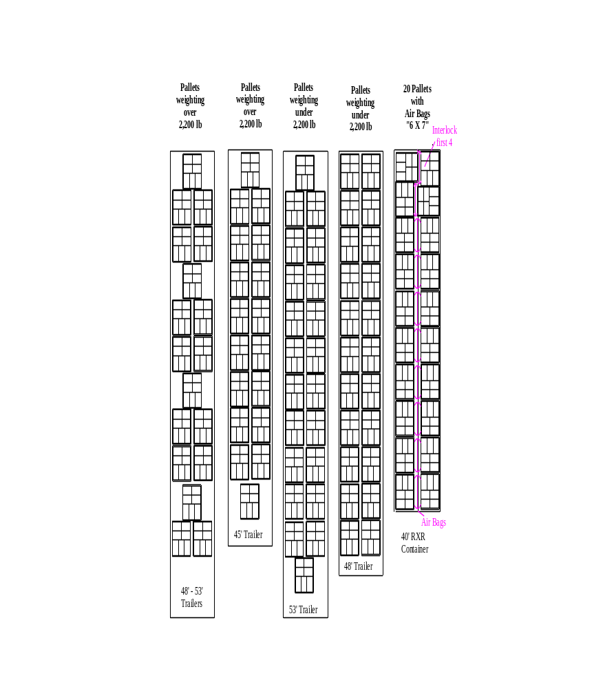

TRAINING DOCUMENTATION

 | EMPLOYEE | TITLE | SIGNATURE | DATE
1
2
3
4
5
6
7
8
9
10
11
12
13
14
15
16
17
18

Revision  Number | Revision  Date | Revision  Author | Revision Description
00 | 11/14/2005 | JB | New Document
01 | 01/28/2009 | JB | Added Jack Stands

